VPC-TASK -2

1. Create one VPC, with 1 public subnet and 1 private subnet.

Create one VPC

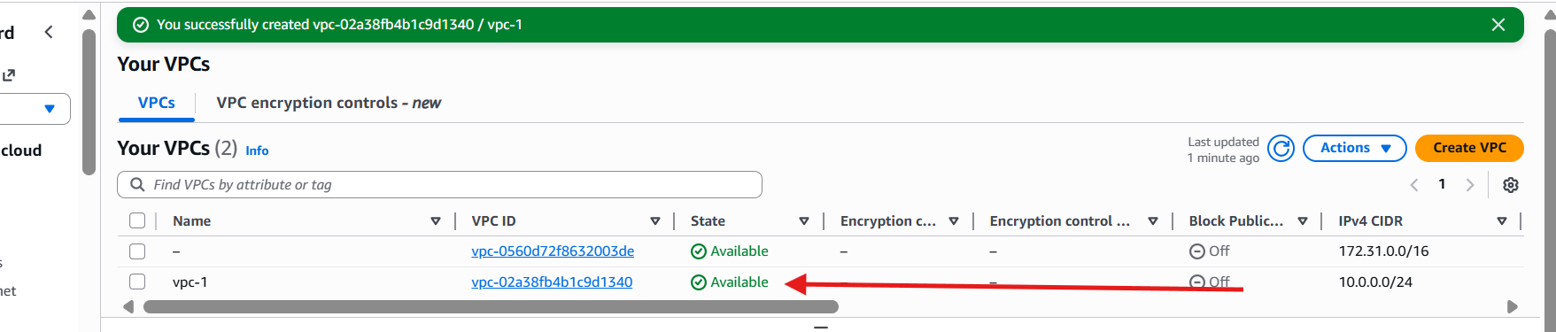

Create 2 subnets one private and one pub

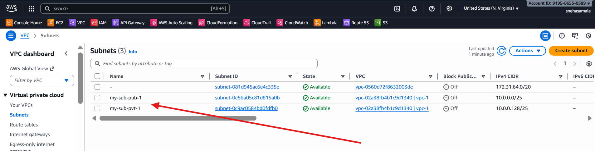

Create 2 Rout Tables

One pub and one private

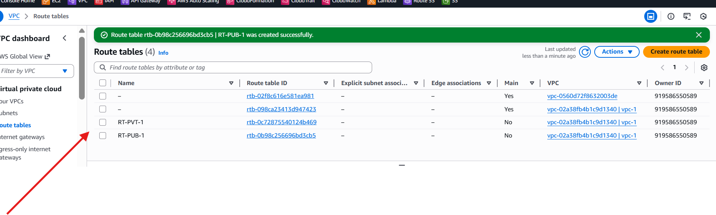

Create one internet gateway

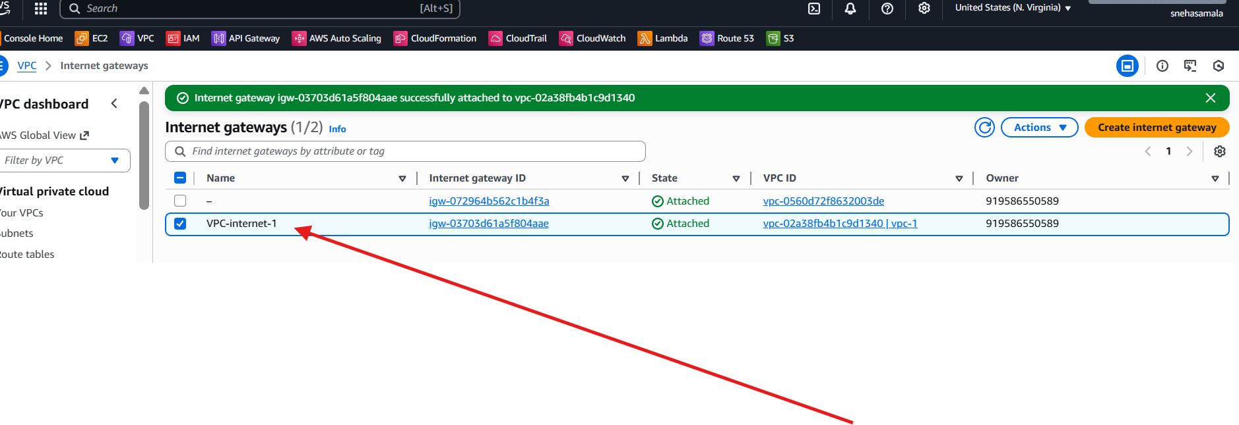

Internet gateway attach to the public sub

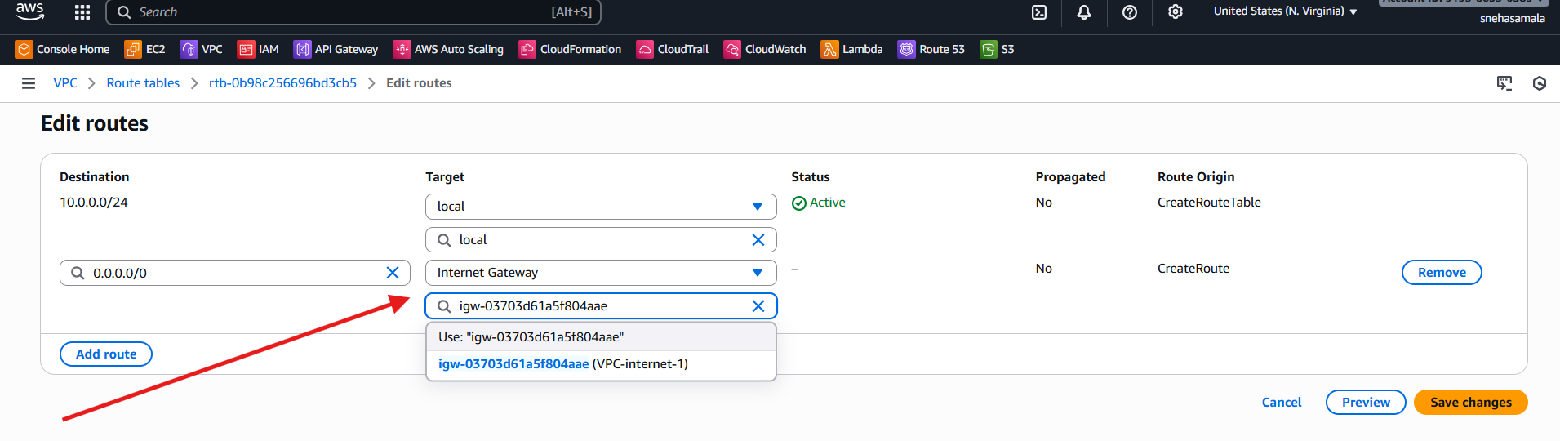

Create one natGW

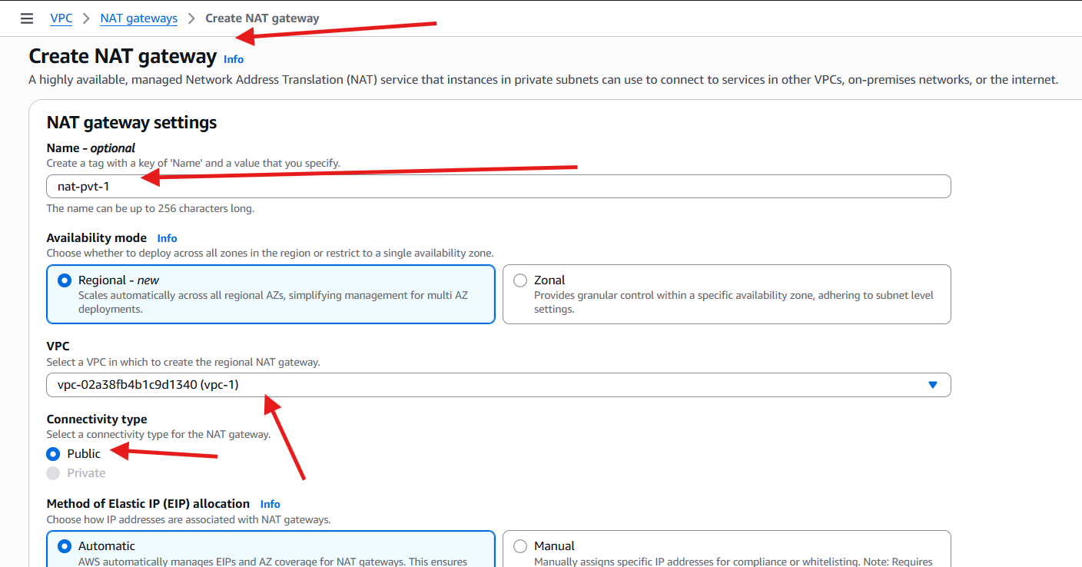

Rout table addached to the inter for public I attachect internet gateway

For private attached NAT gateway

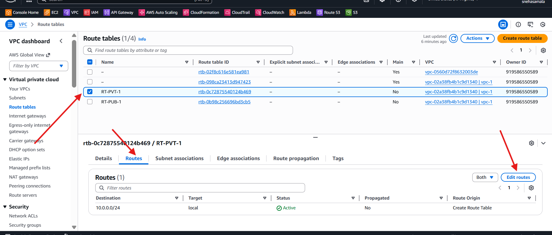

Attached the internet gate way for public rout

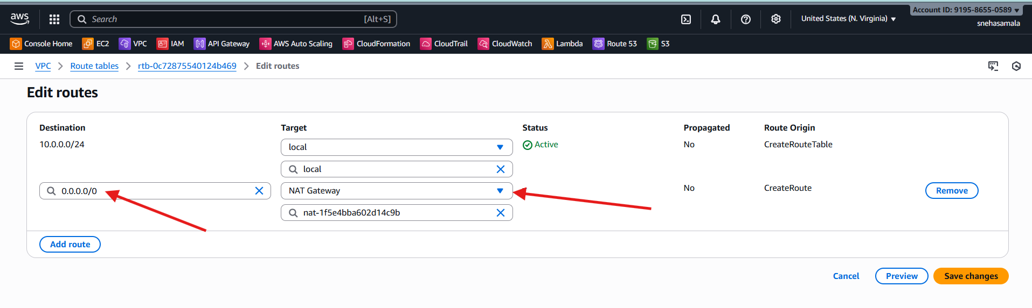

For public I attached nat gate way

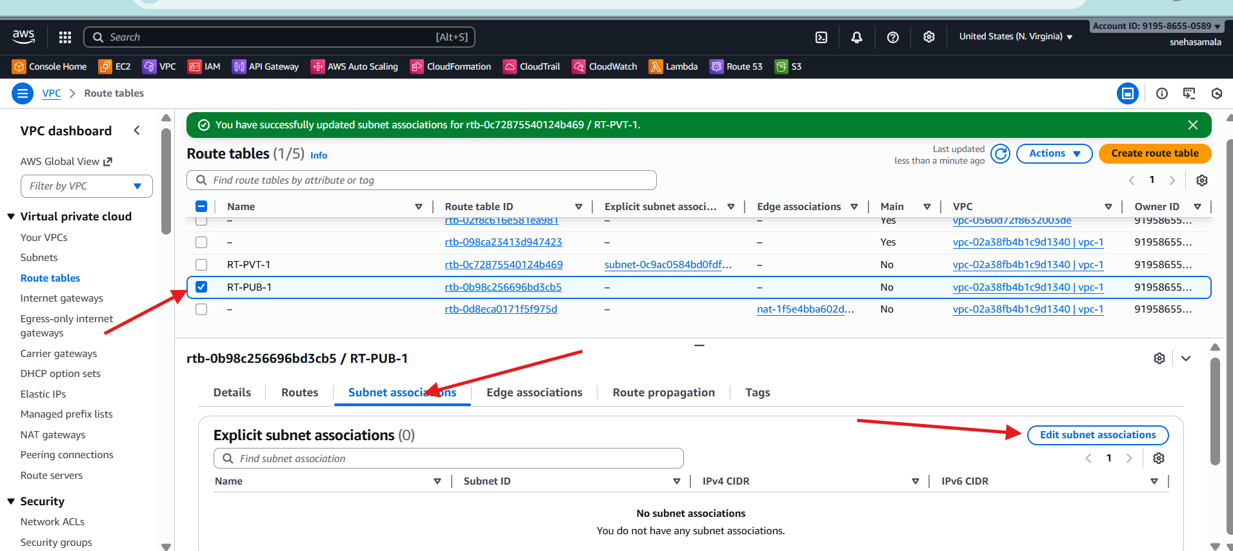

Selected my public subnet and attached to Rout Table public

For private I attached private rout

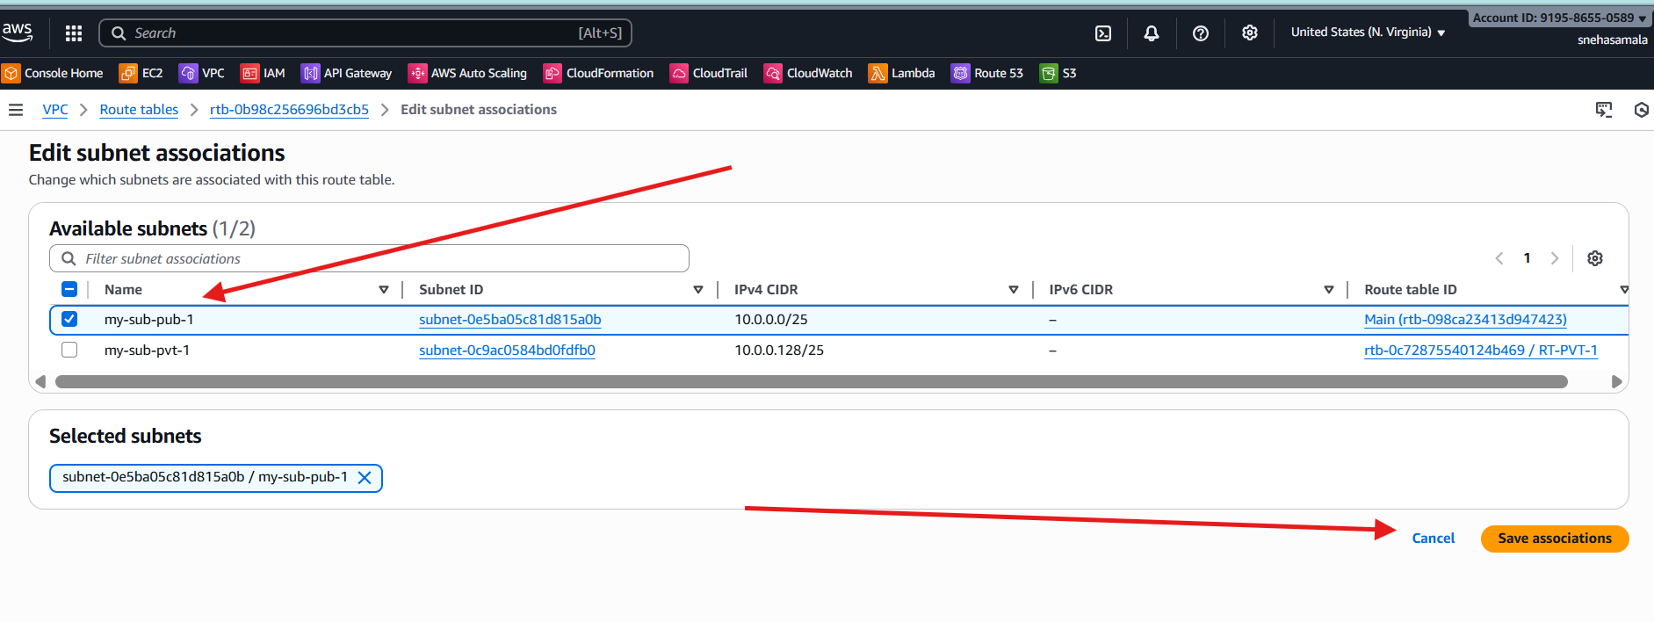

Vpc resource Map

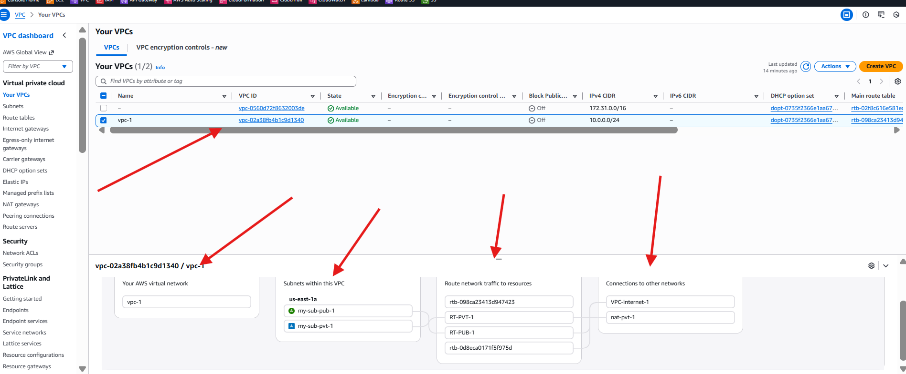

1. Enable VPC peering for cross-region.

Region is set for 🡪Europe(lreland)

Launch one ec2

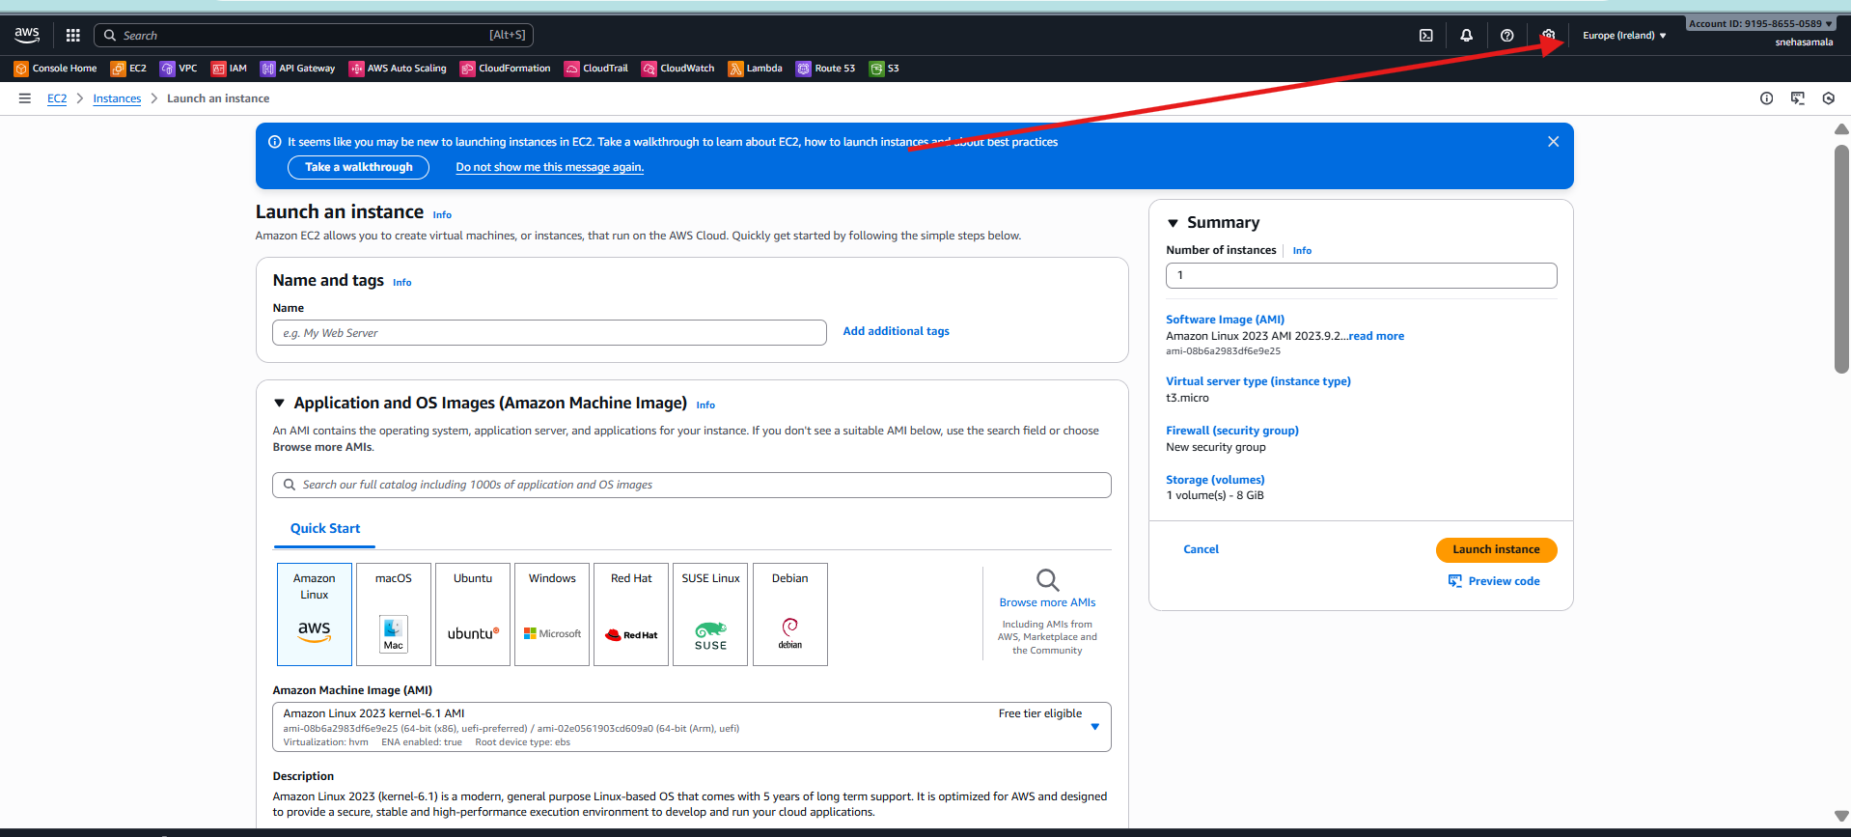

Give required networs and security

And launch the instance

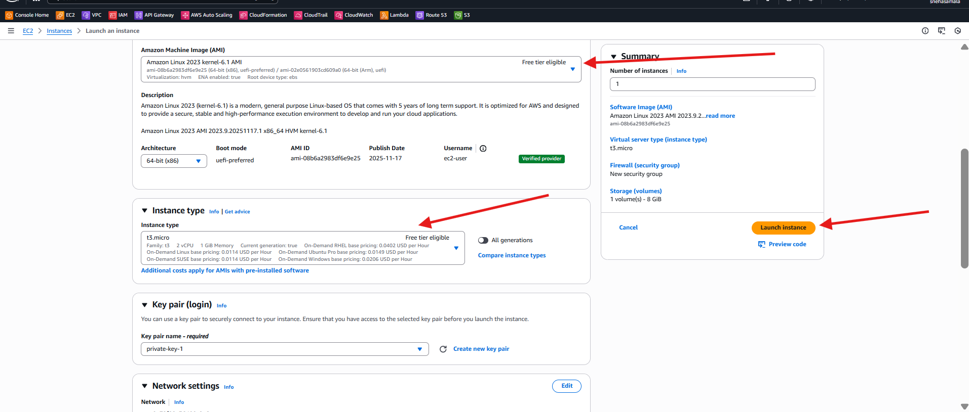

**Change the region**

**Ohio regio**

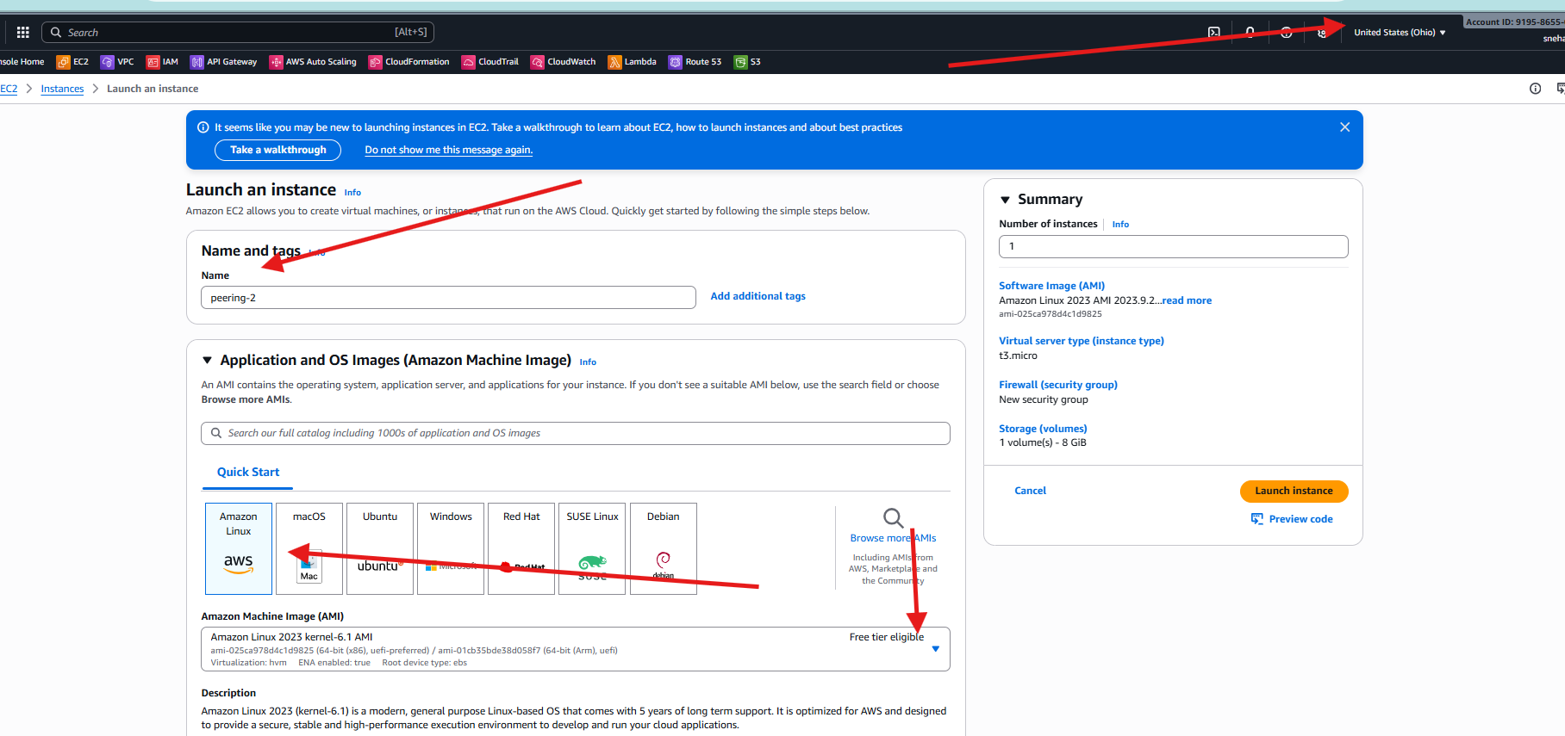

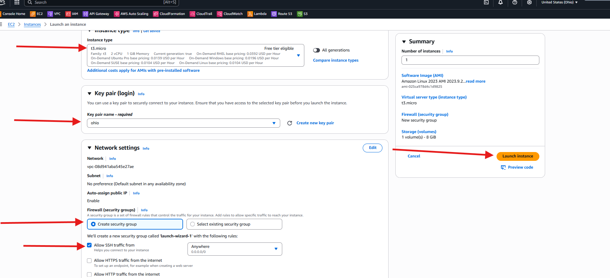

**Ec2 is successfully launched**

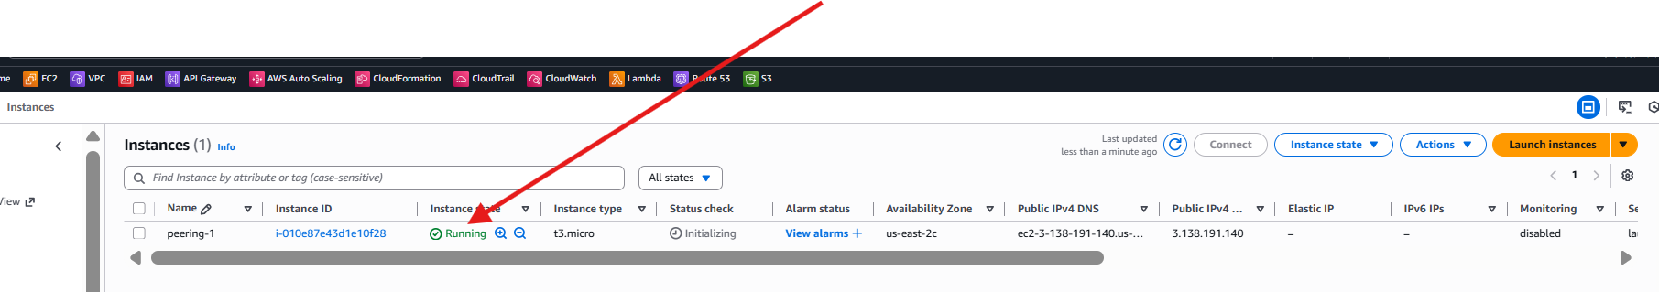

**Create one VPC**

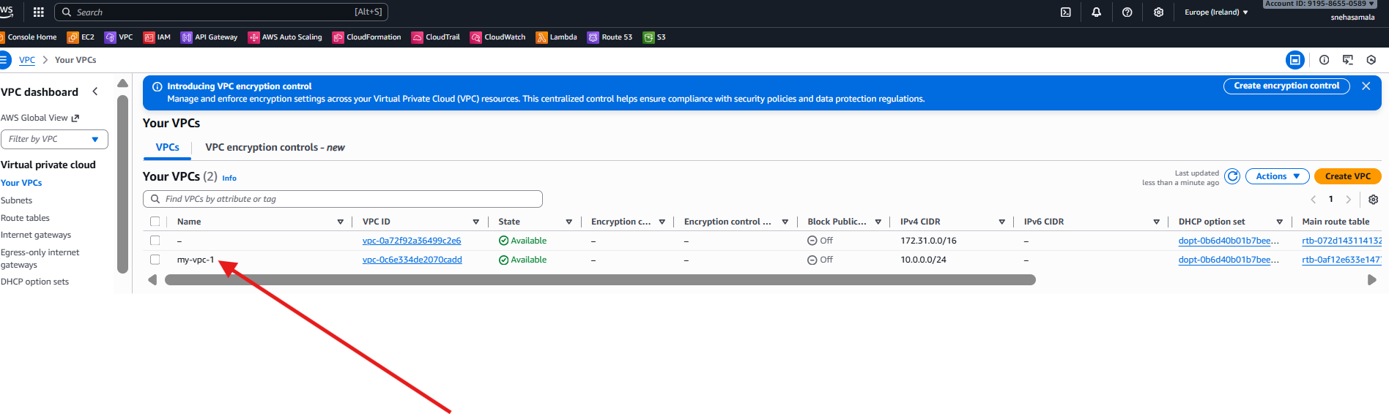

**Go to the peering connection**

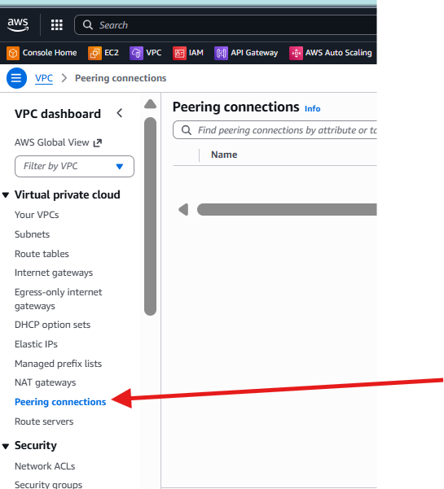

**Create the peering connection**

**Create peering connection 🡪select local VPC peering 🡪vpc id : kept default**

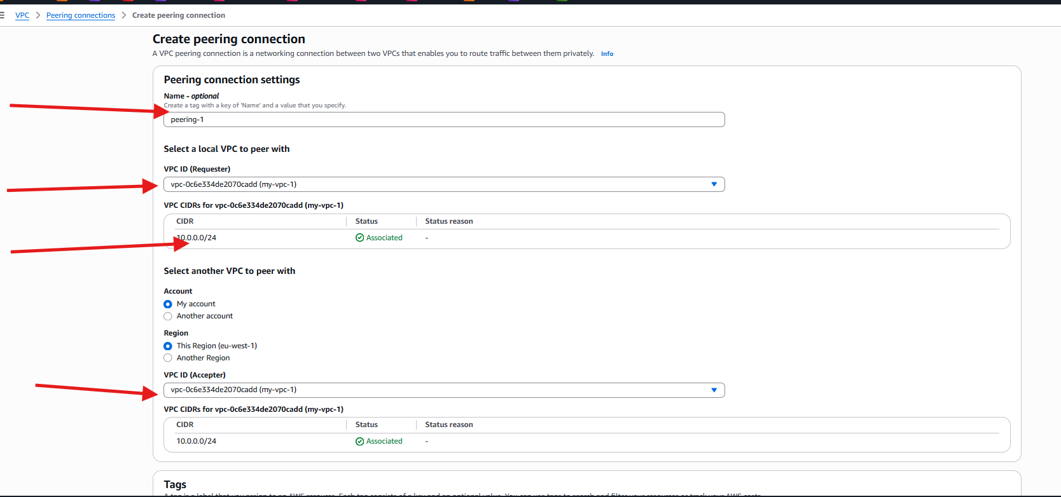

**Go to the another region 🡪 VPC🡪Your vpc🡪already default VPC**

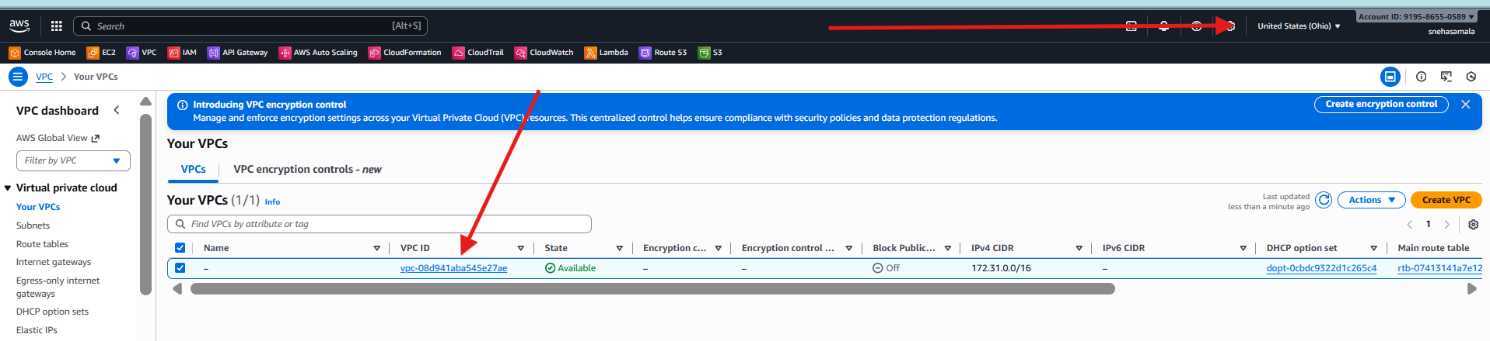

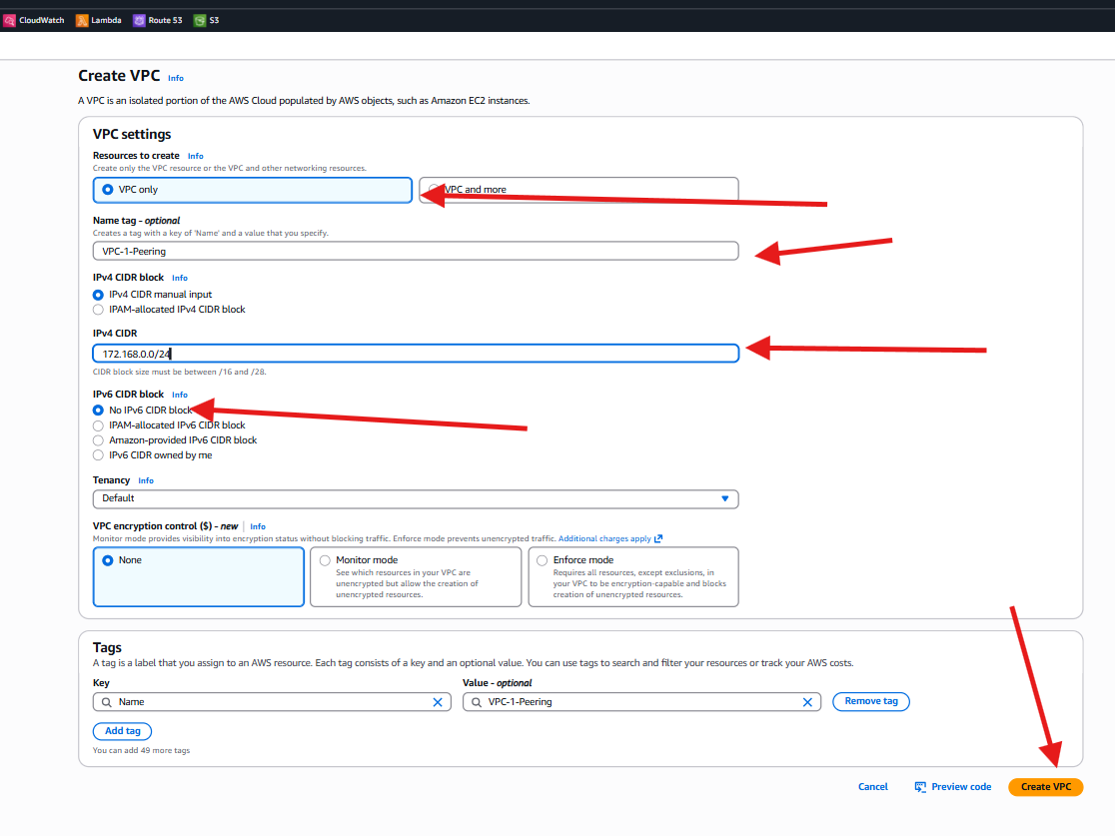

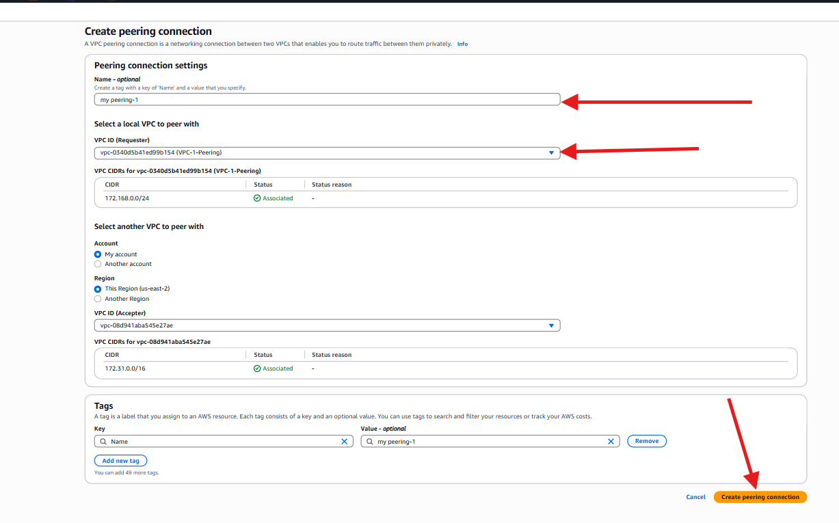

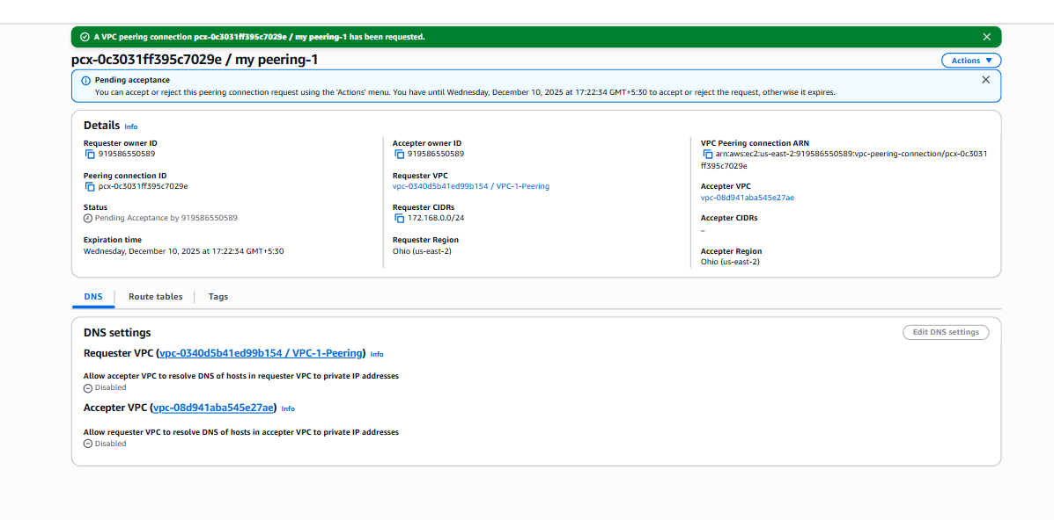

**Go to the Ireland region**

**Select vpc peering🡪select your🡪 peering connection🡪actions🡪accept request**

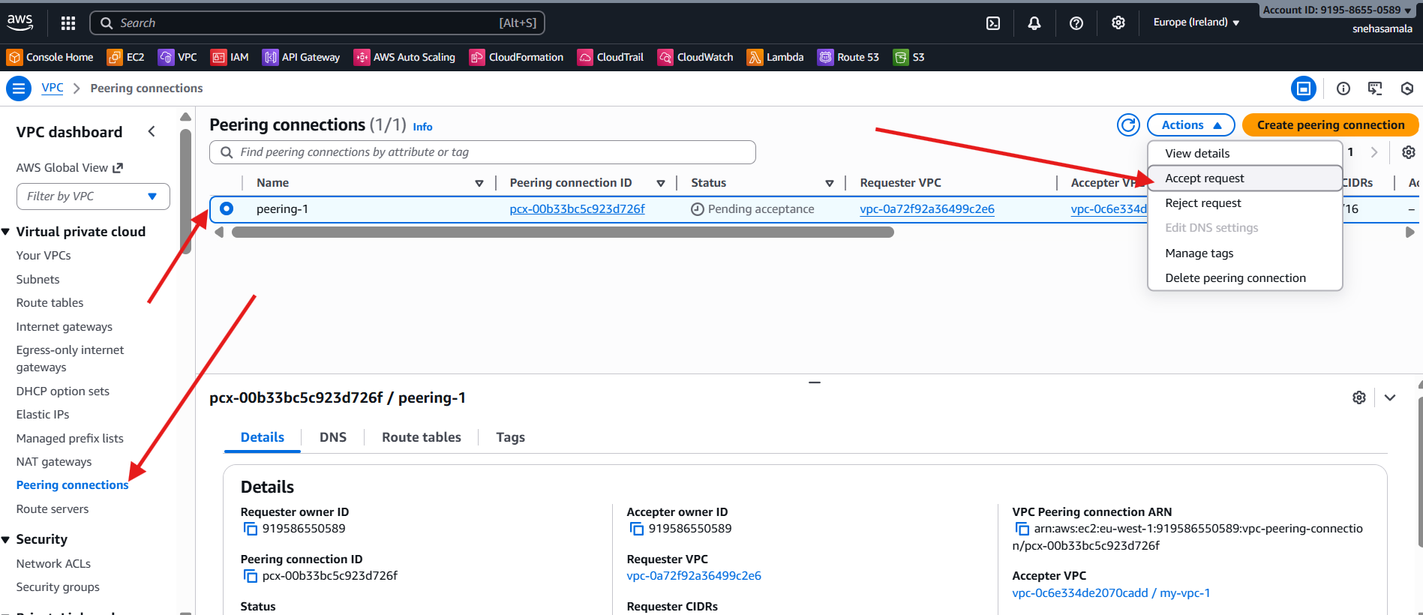

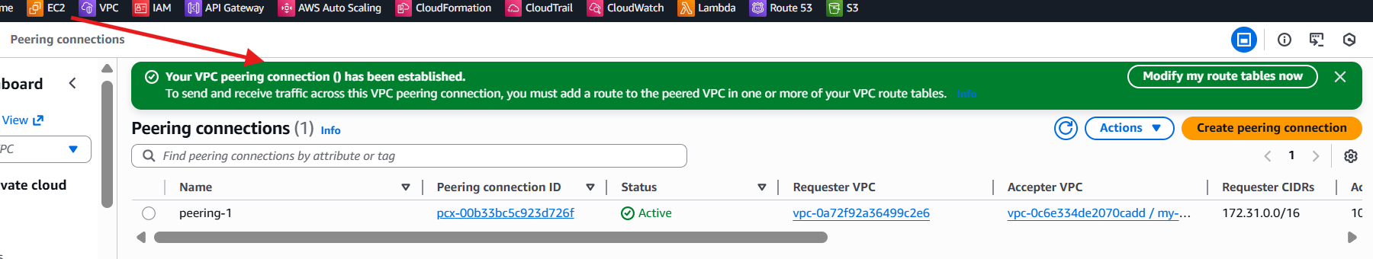

**Go to the ohio region**

**Select RT🡪Create RT🡪give the name🡪select vpc🡪and create RT**

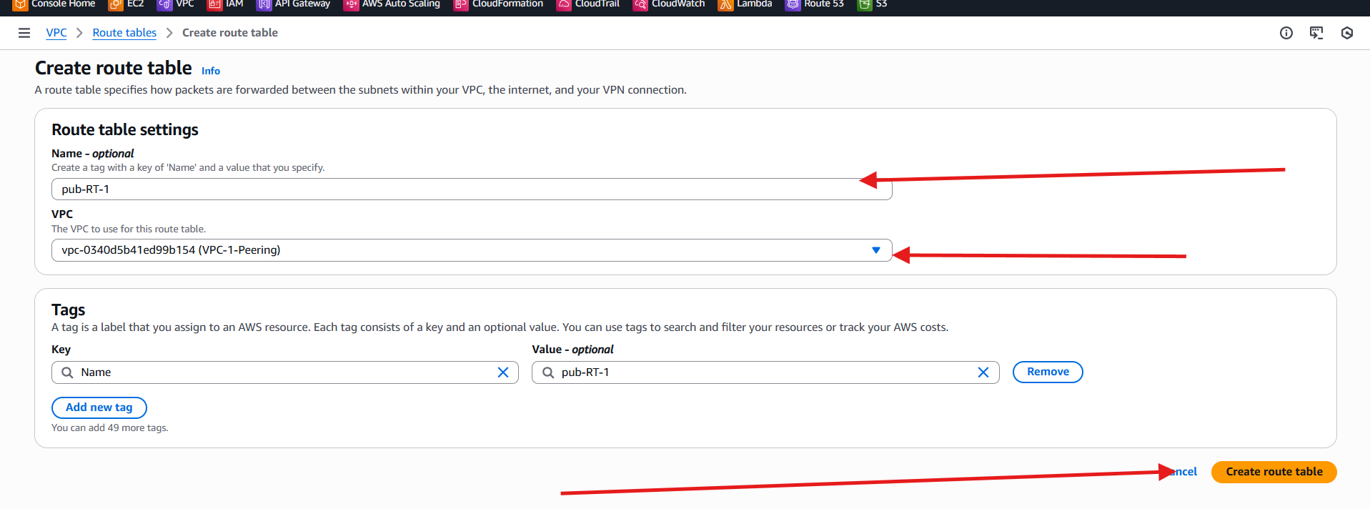

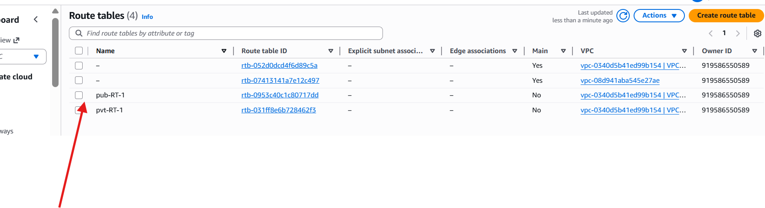

**Create internet gateway and attach to the vpc**

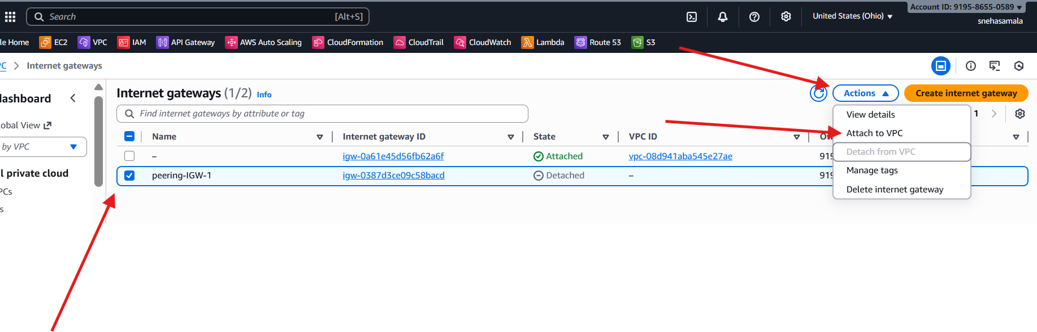

**Go to the rout table and attach to the internet gate way**

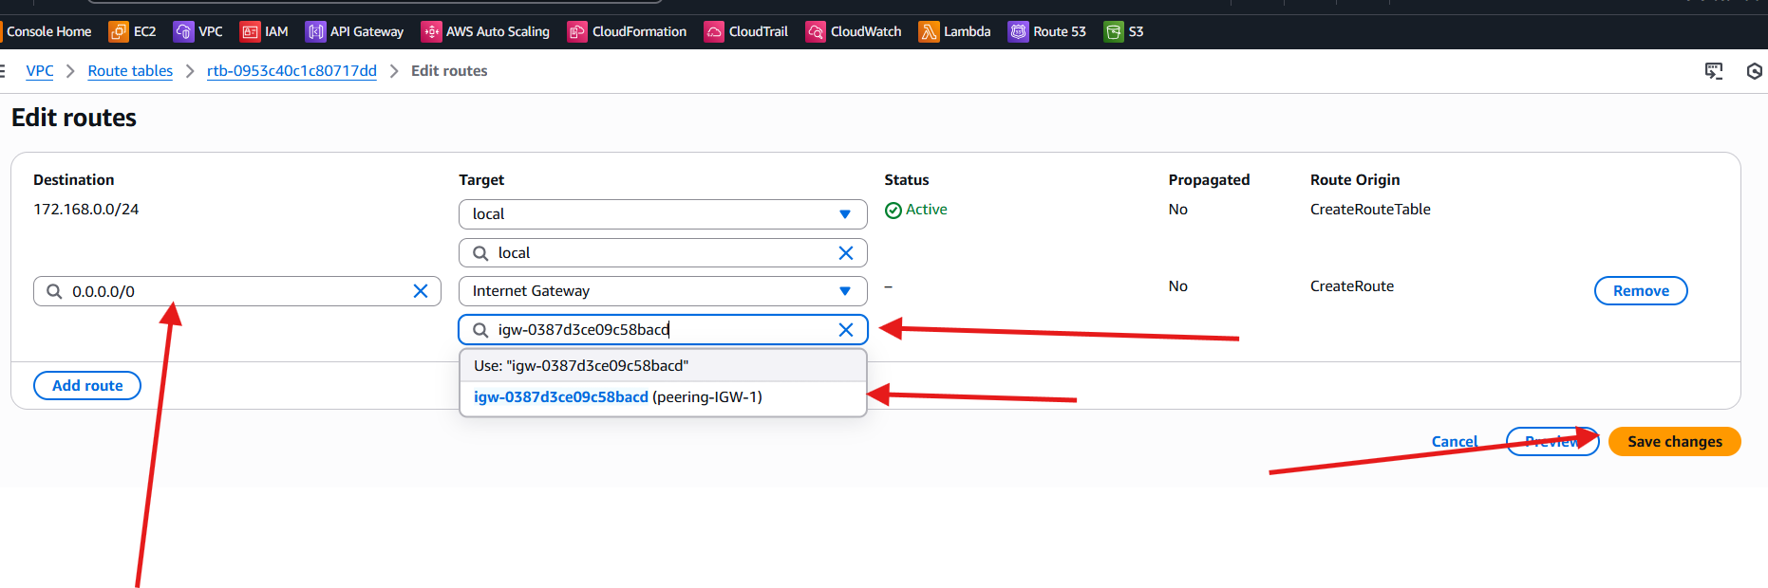

**Internet gate way is attached**

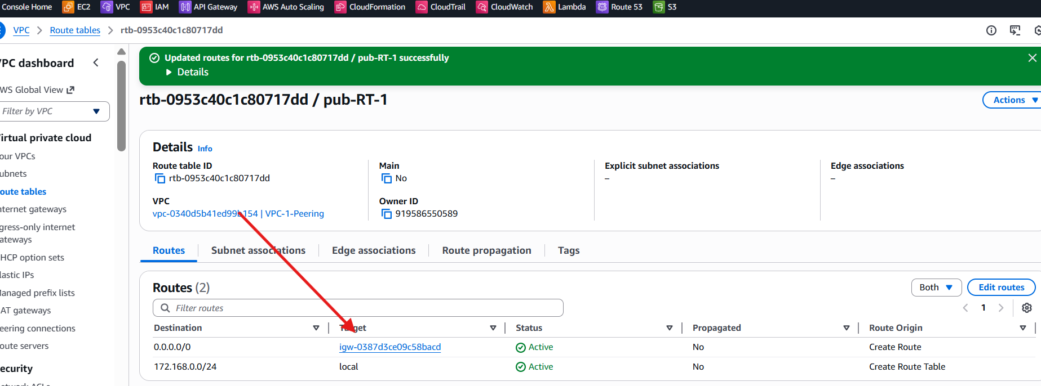

**Change your region to lreland**

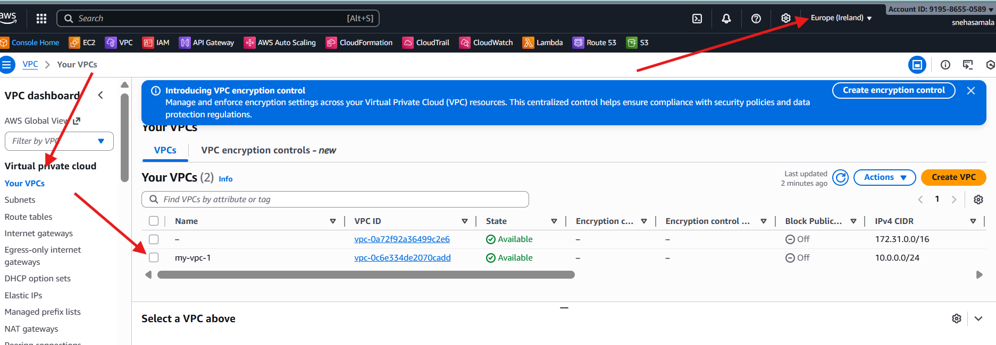

**Go to the ohio region🡪RT🡪**

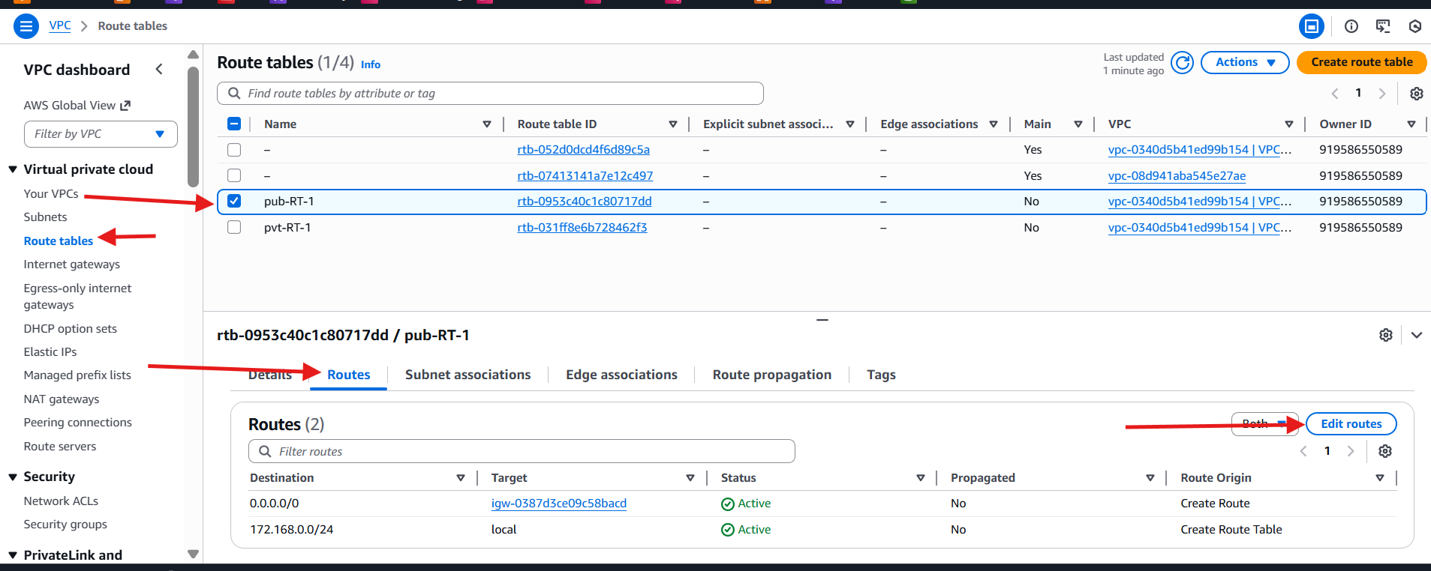

**Go to the destination🡪select ip🡪select target🡪peering connection**

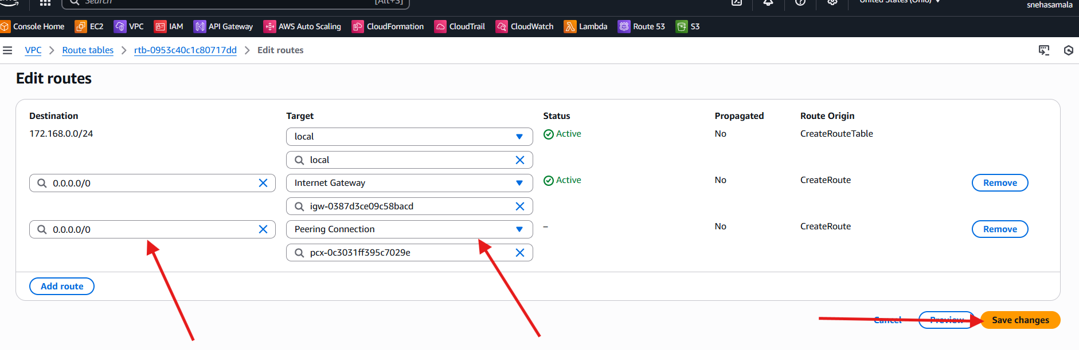

**Successfully connected**

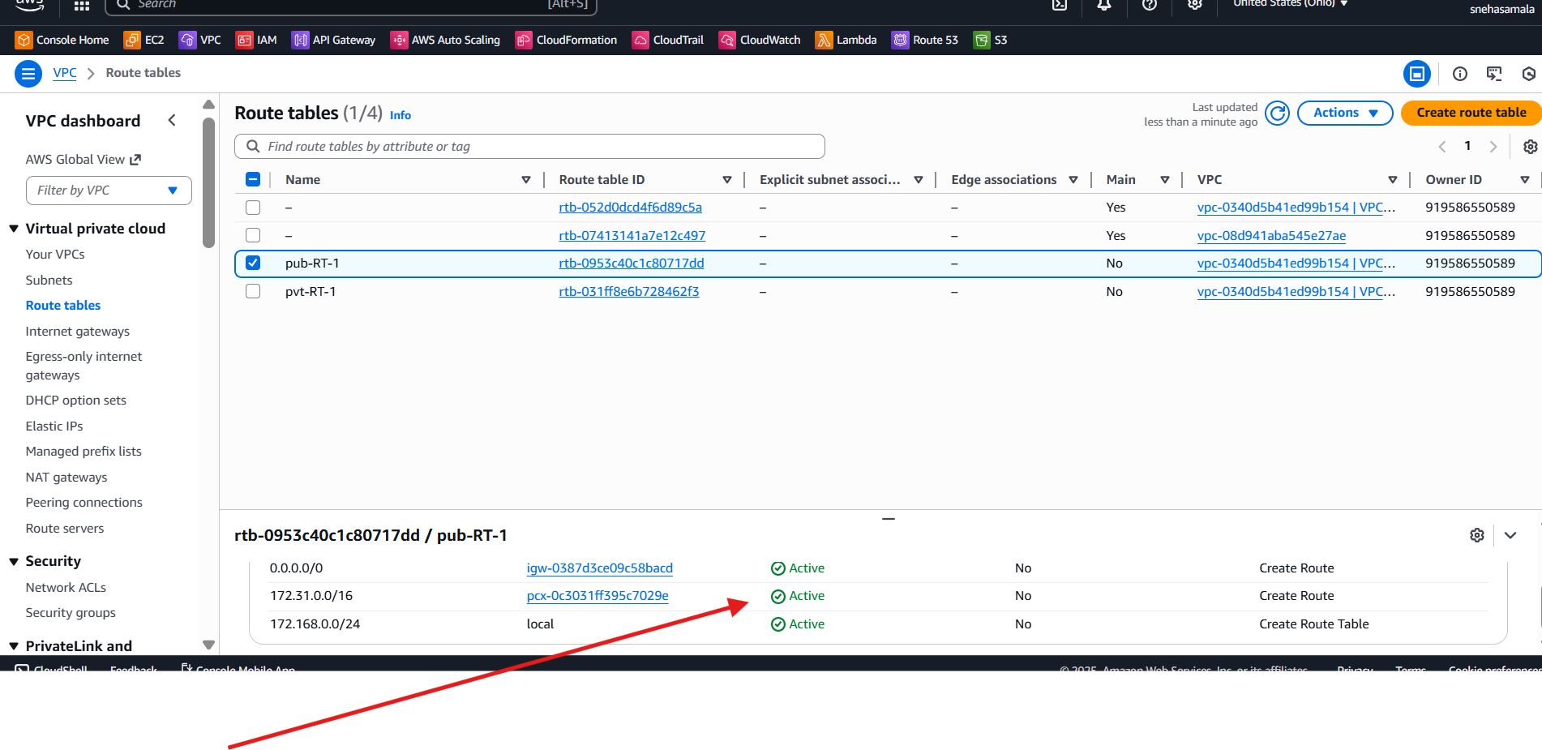

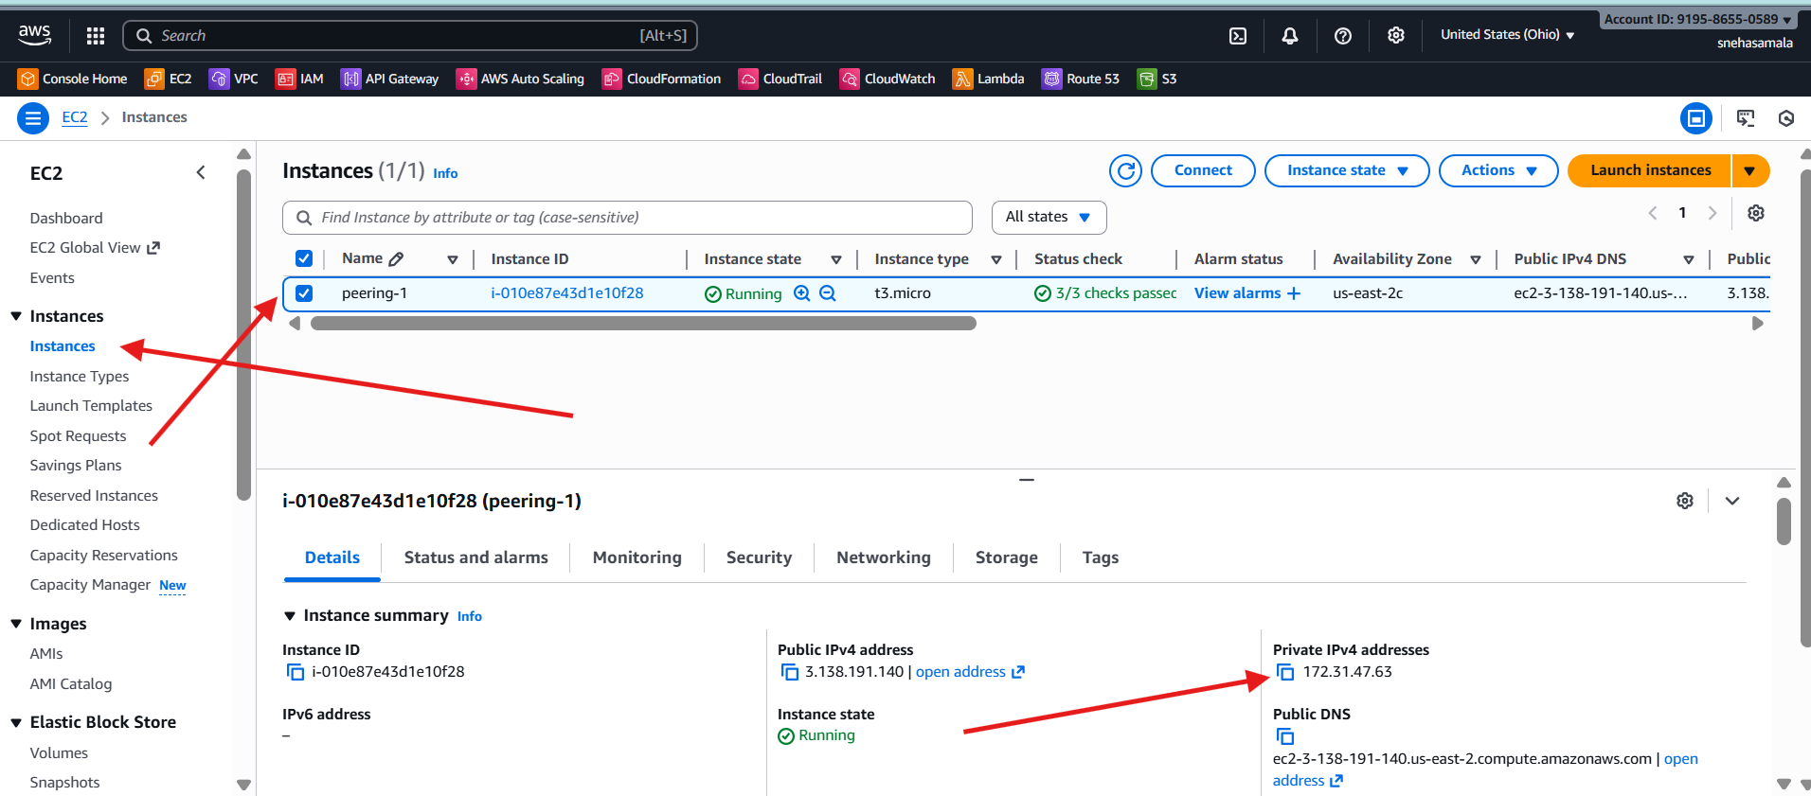

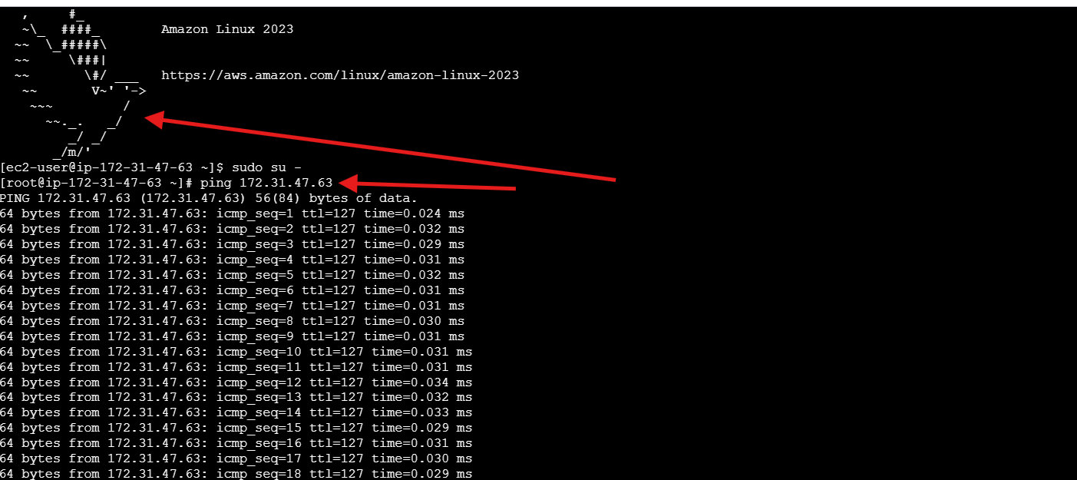

1. Enable VPC peering for cross-account (you can collaborate with your friend to do this task)

Created one VPC

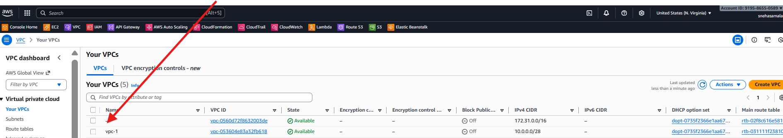

Done with details

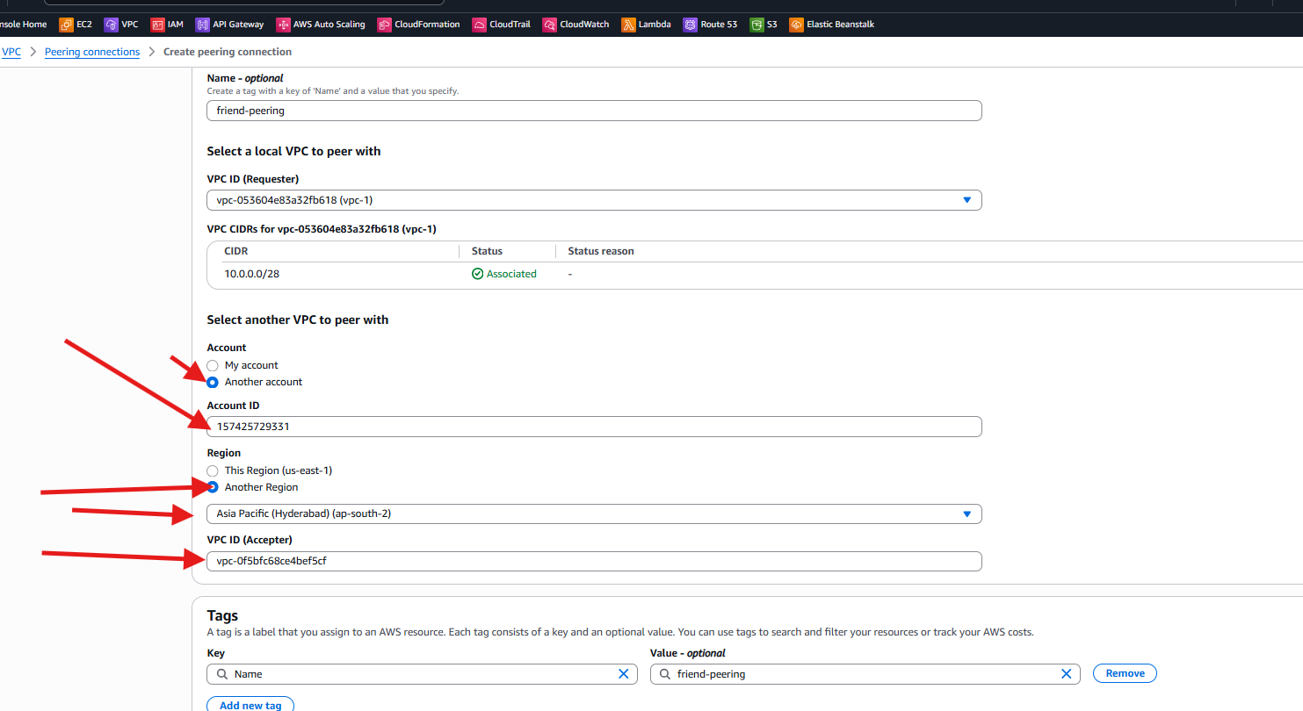

Total details of peering with another account

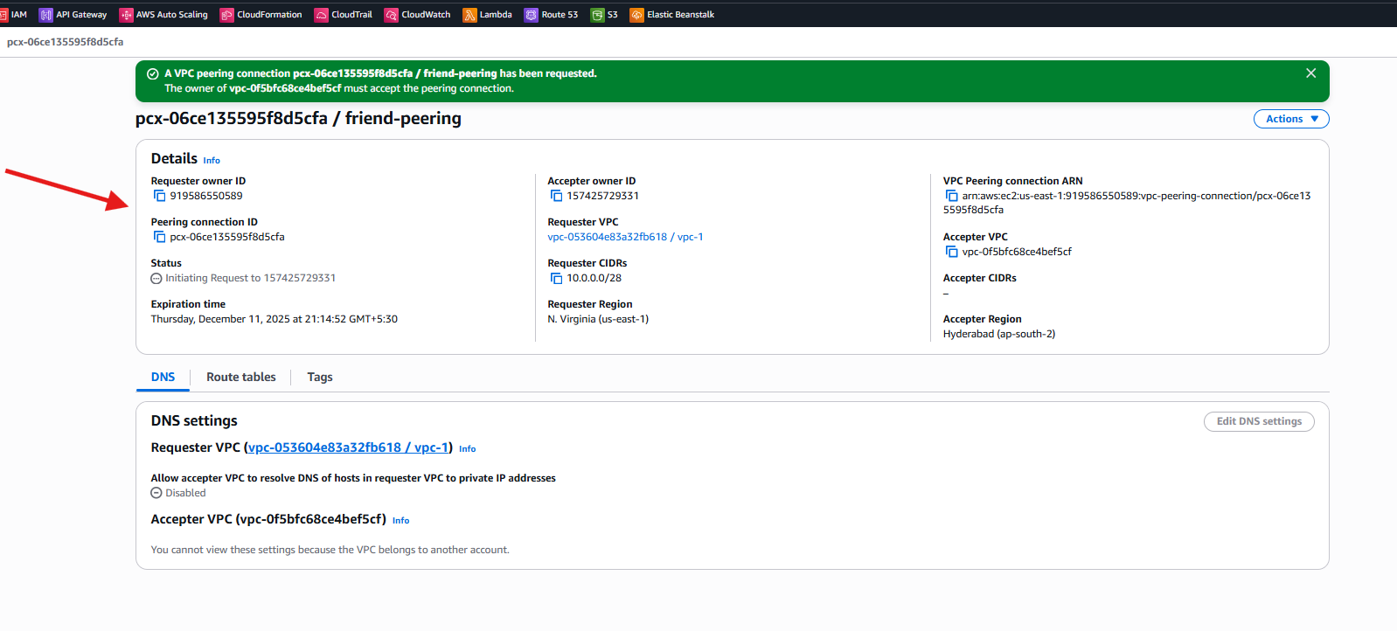

Successfully connected

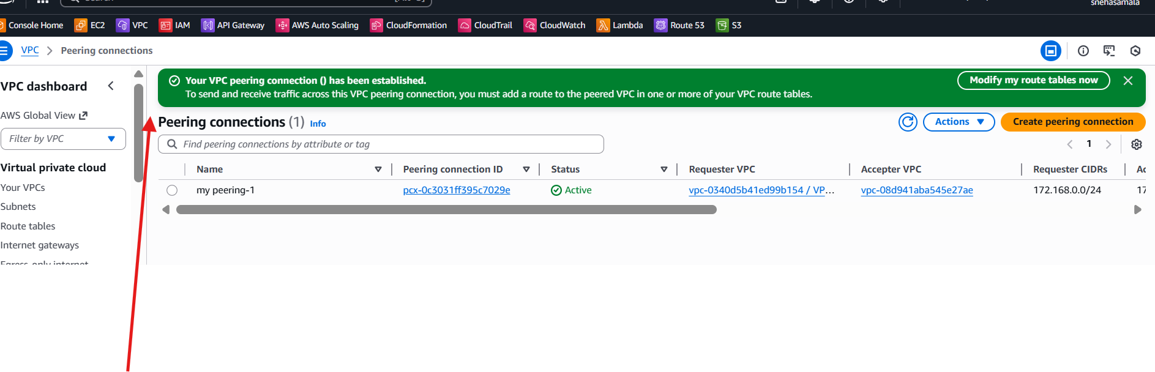

1. Set up a VPC Transit Gateway.

Create 3 vps

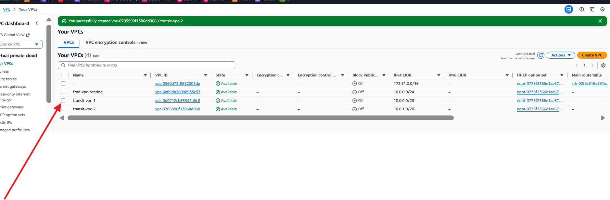

Create subnets for 3 vpc’s

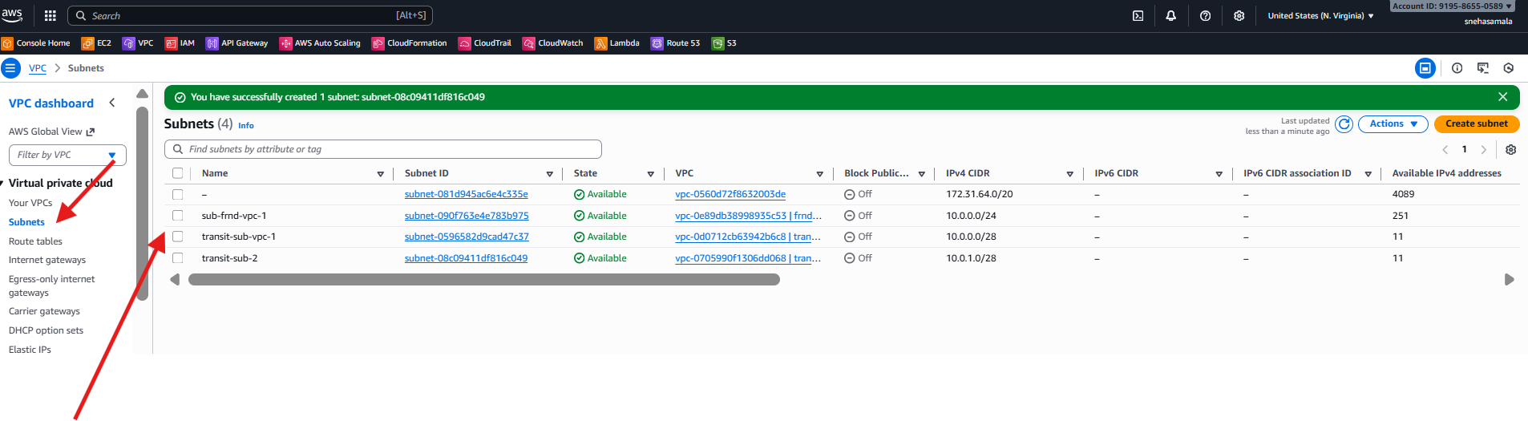

Launch 3 ec2 instances🡪attach vpc

For each instance attach he one on one vpc including with subnets

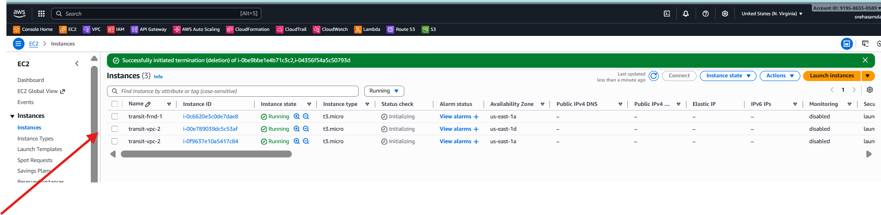

Add in bound rules

Ssh 🡪22

All traffics 🡪 all

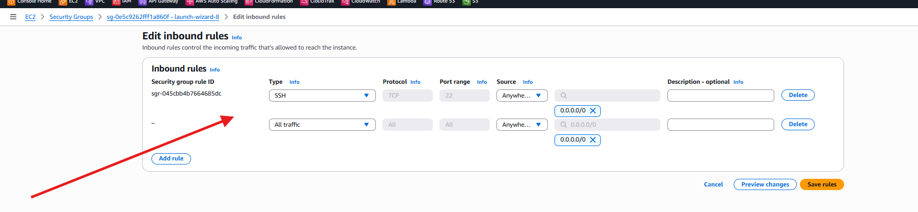

Create transit gateway attachment and attach vpc’s

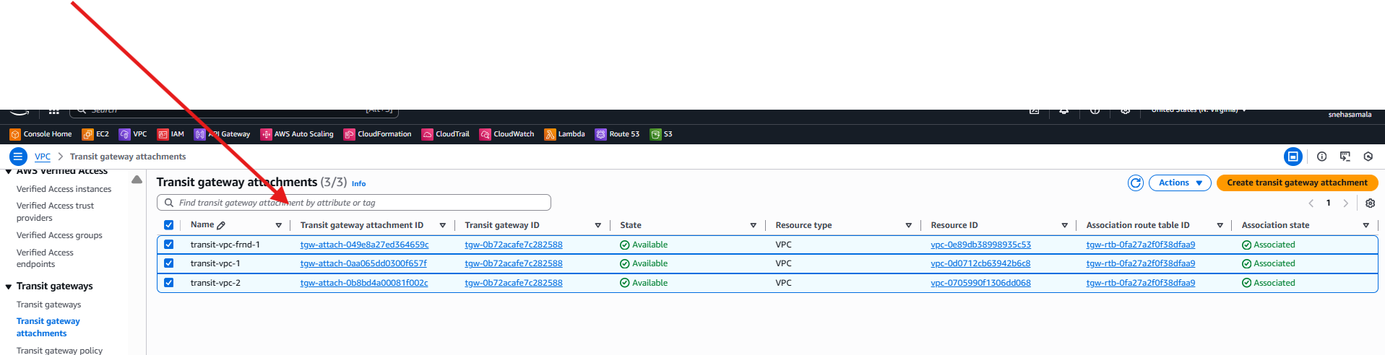

Create 1 rout

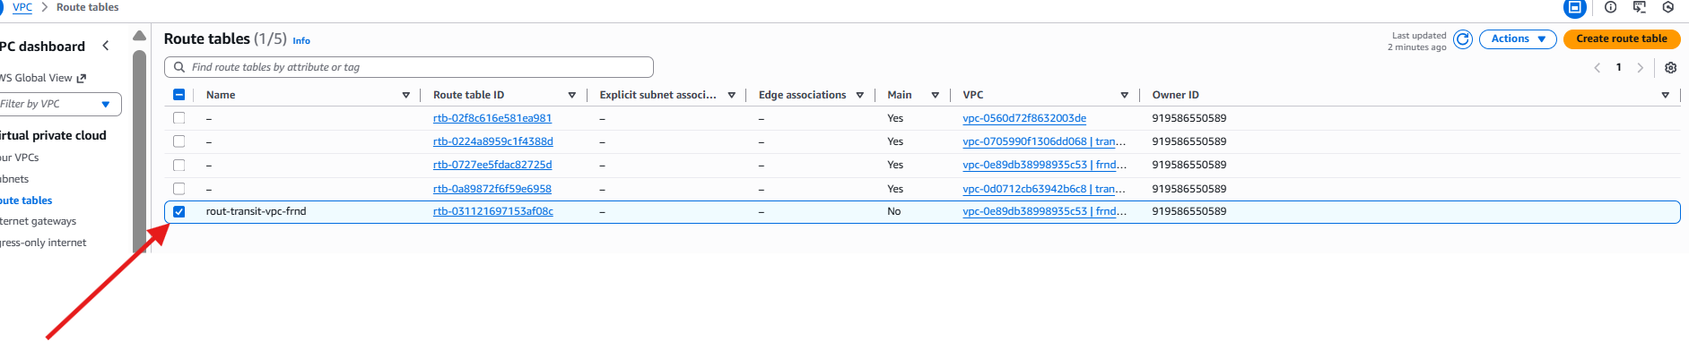

Select RT 🡪 routs 🡪 edit rt

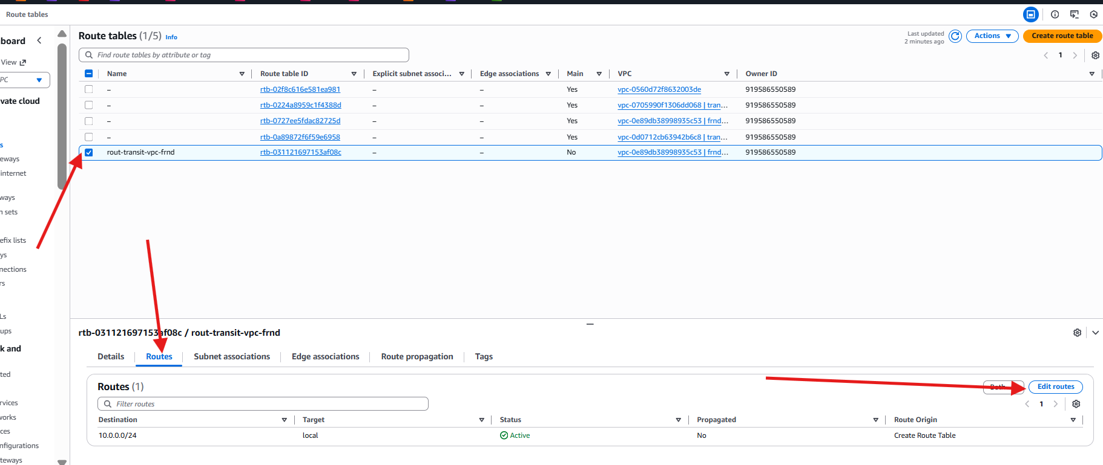

One instance is connected

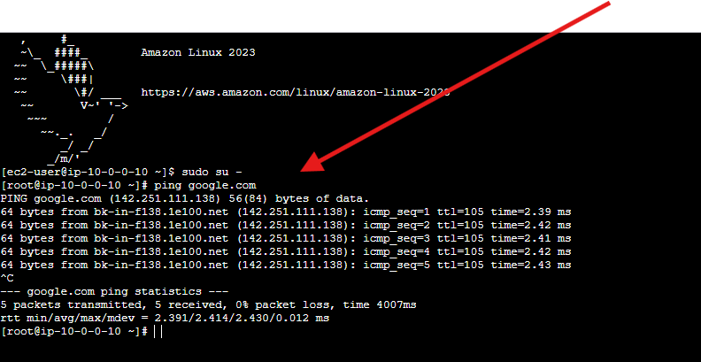

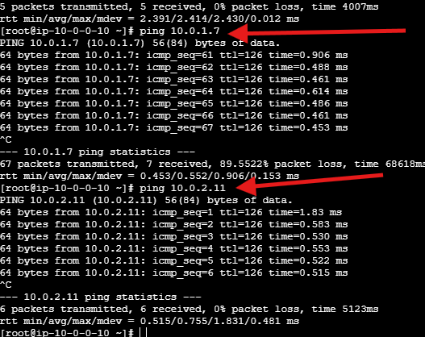

1. Set up a VPC Endpoint.

Created vpc

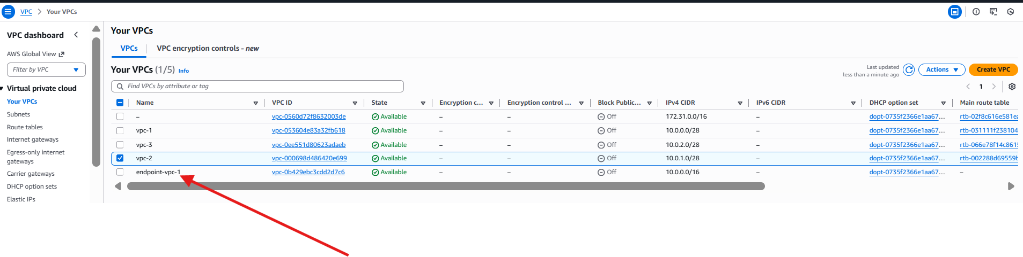

Created internet gate way

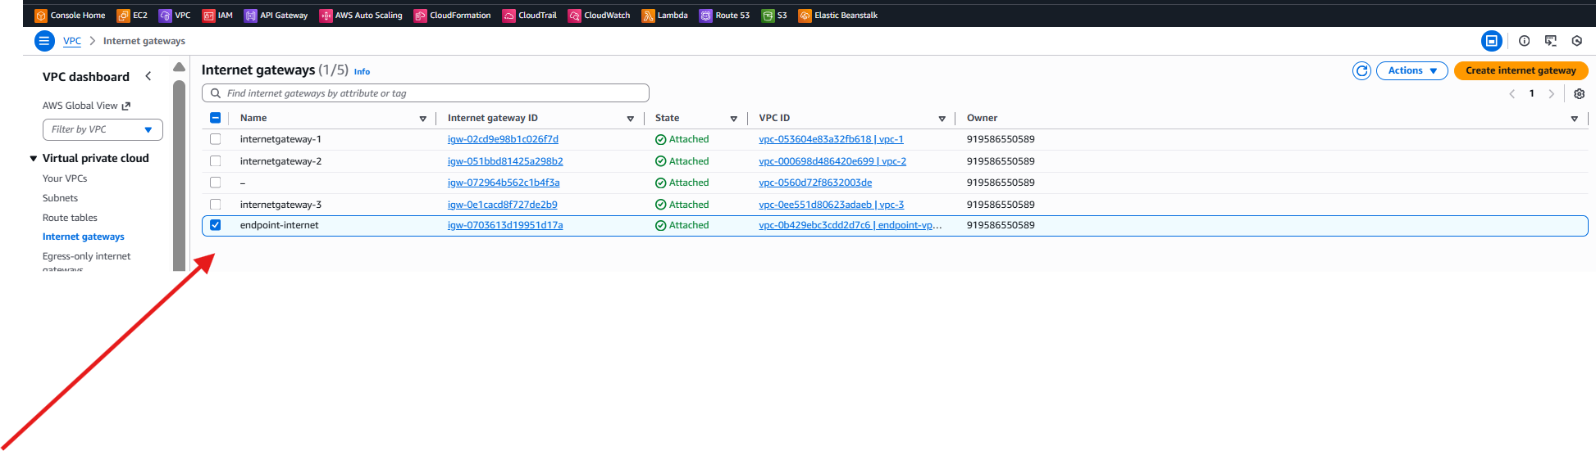

Attached to the vpc

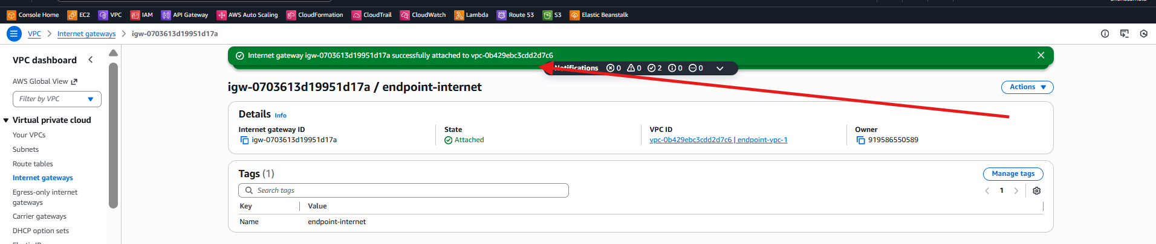

Created endpoint

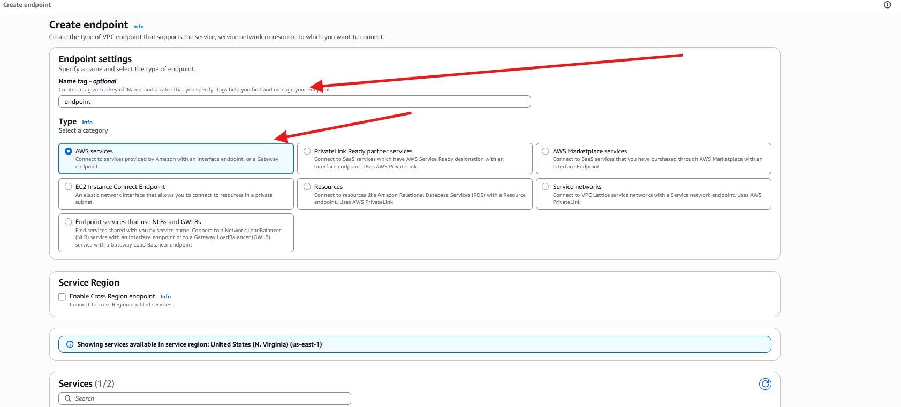

Attached to the vpc

And rout table

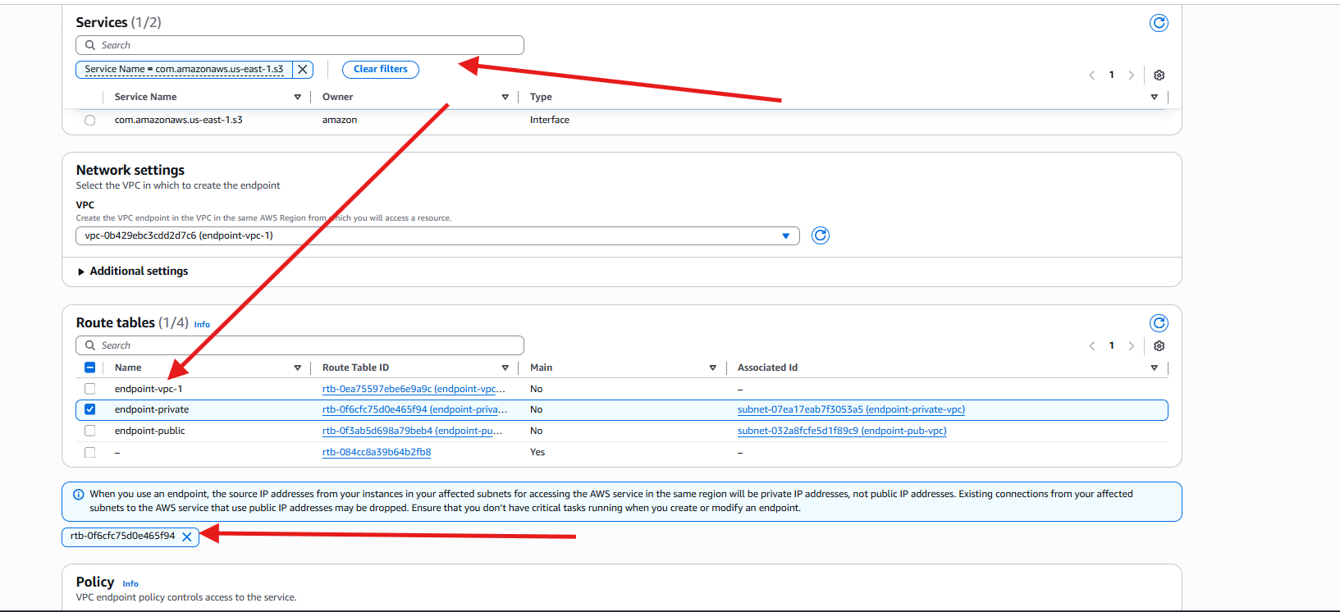

Successfully endpoint is completed

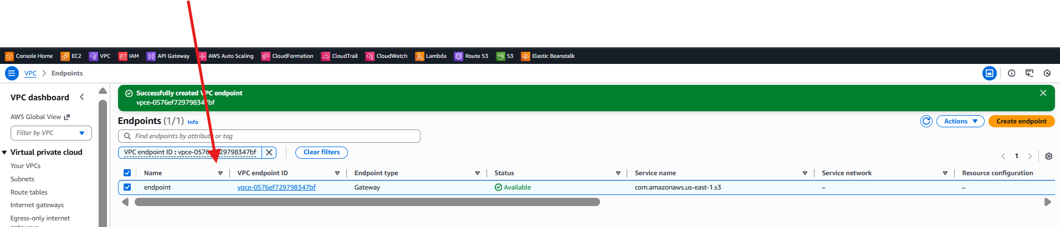

Created rout table

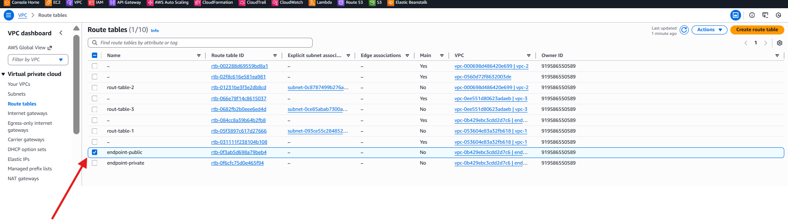

Edit routs

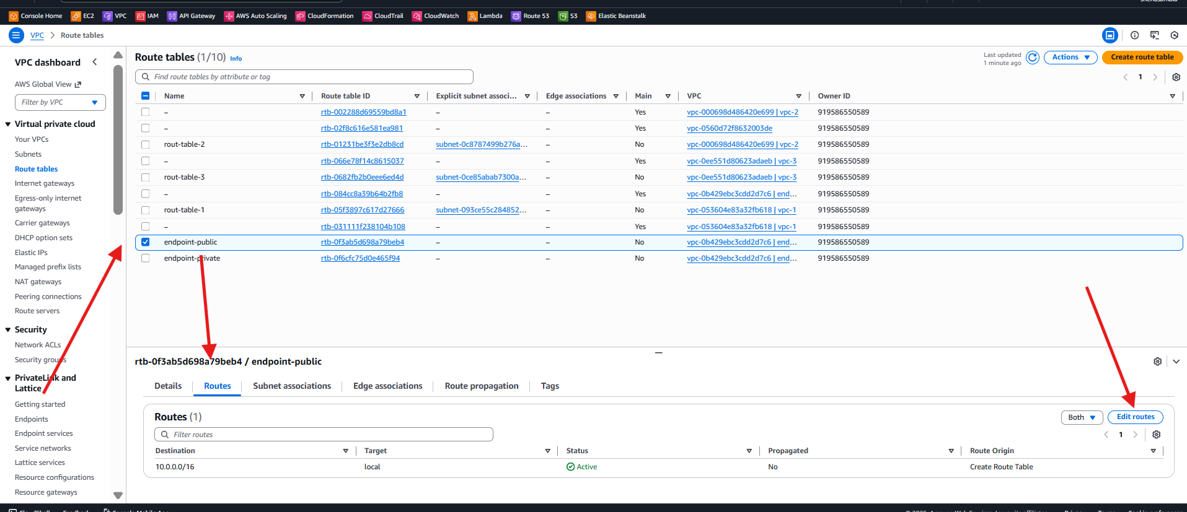

Attached internetgate way

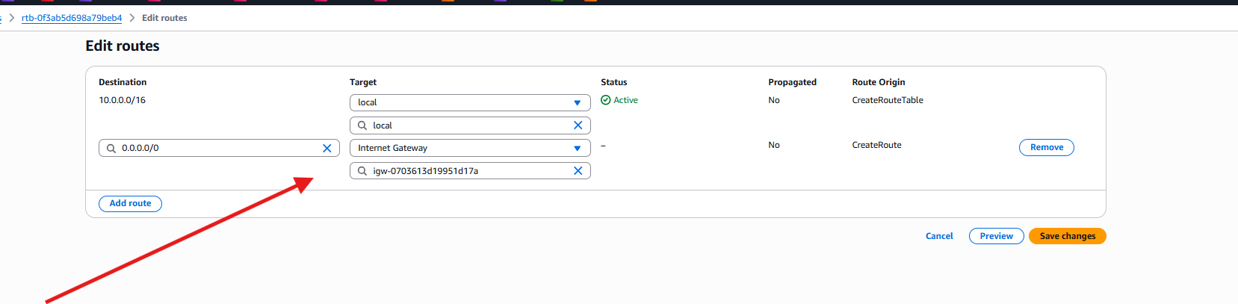

Launched 2 instance attached vpc and attached 1 sunnet-pub

For 2nd instance attached vpc -attached private subnet

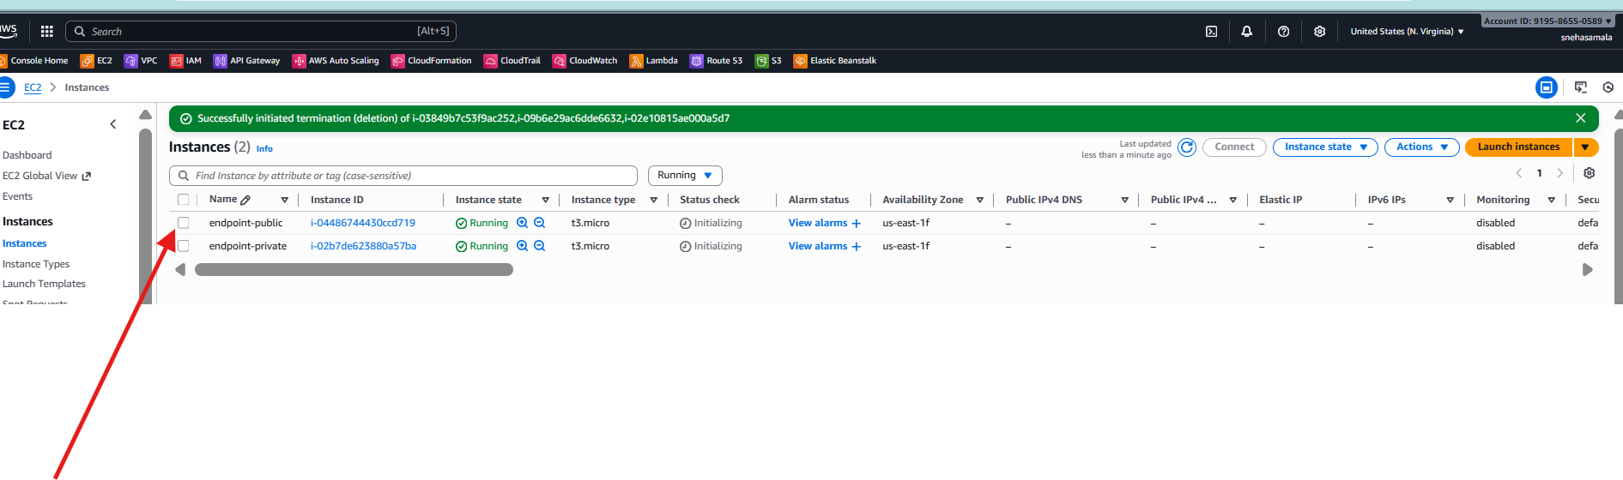

Created s3 bucket

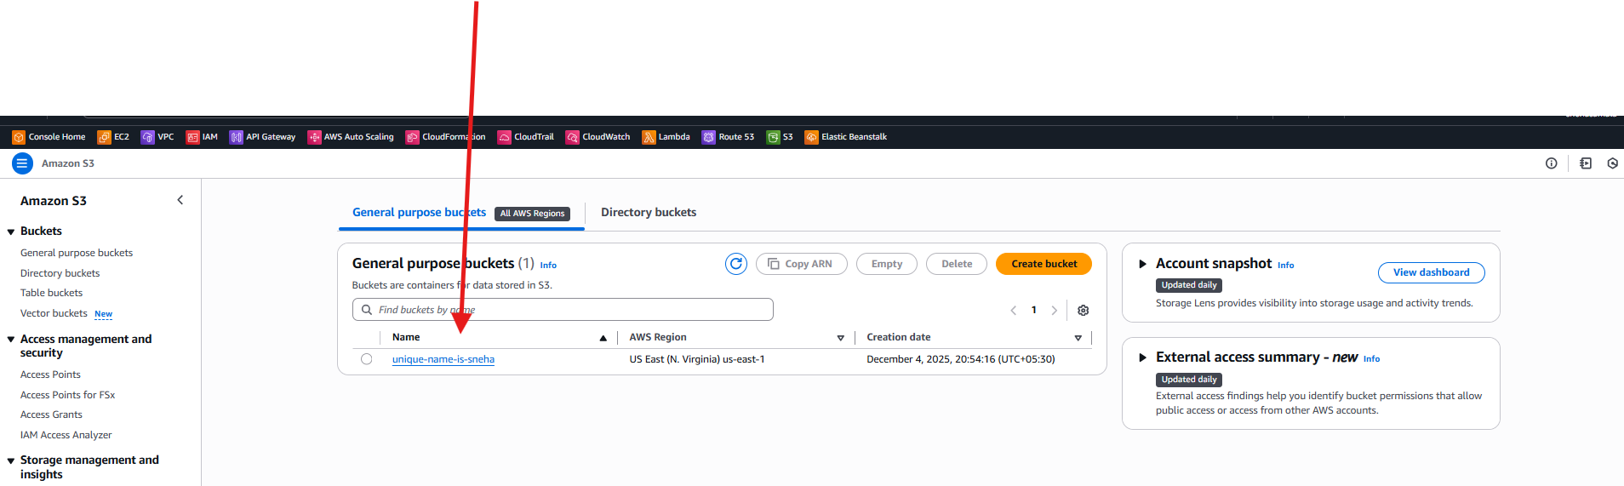

Public is connected

Connected public instance

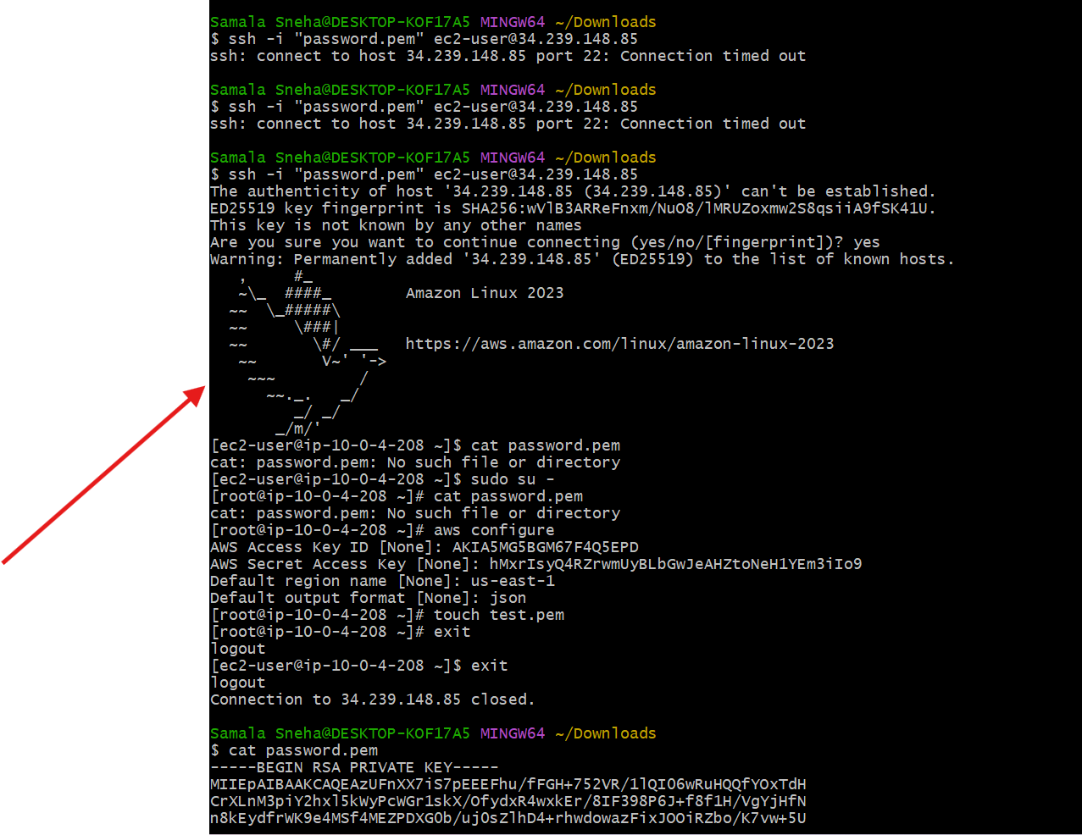

Connected private instance

